We want to run an Email Campaigns for customers of Store 2 (First, Last name, and Email address of customers from Store 2)

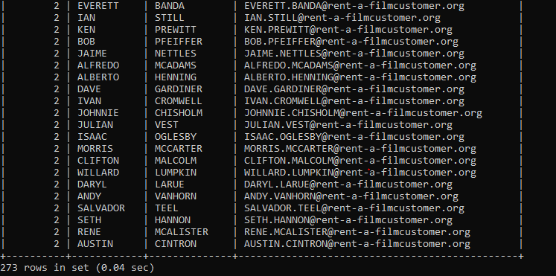

List of the movies with a rental rate of 0.99$

select store_id,first_name,last_name,email from customer where store_id ='2';

select rental_rate,title from film where rental_rate = '0.99';

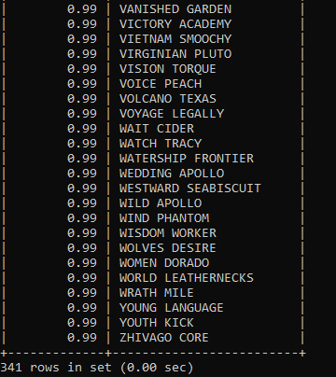

Your objective is to show the rental rate and how many movies are in each rental rate categories

select rental_rate,count(title) from film group by rental_rate;

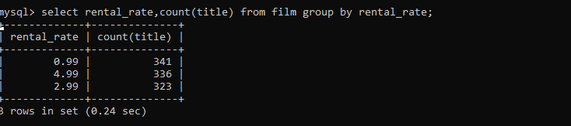

Which rating do we have the most films in?

Select rating,title,release_year,count(rating) from film group by rating;

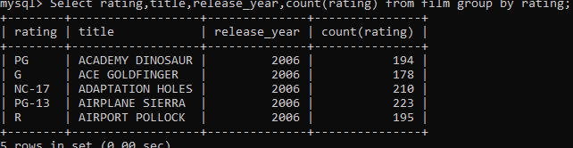

Which rating is most prevalent in each store?

We want to mail the customers about the upcoming promotion

select store_id,first_name,last_name,email from customer

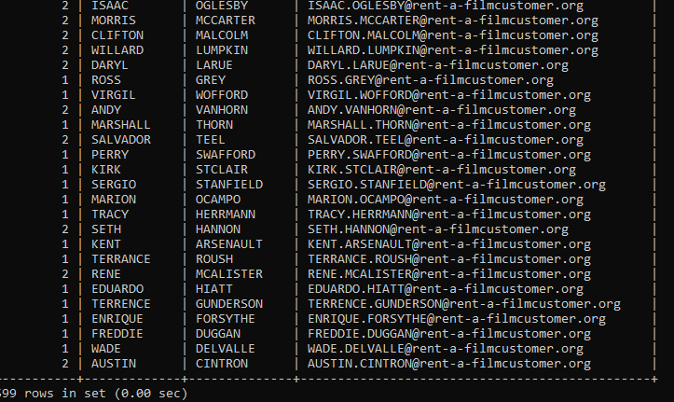

List of films by Film Name, Category, Language

Select a.title,b.name from film a, language b where a.language_id = b.language_id;

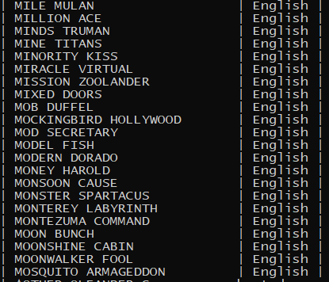

How many times each movie has been rented out?

Select rental_duration,title from film;

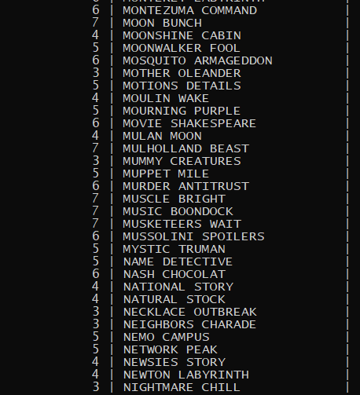

What is the Revenue per Movie?

How many rentals do we have for each month?

Select count(rental_date) from rental group by rental_date;

Which date the first movie was rented out?